Make your mother feel special this Mother’s day with Vegit Ready-to-Cook Snacks
National, 3rd May 2013:

Dedicate a day to your mother, let’s not wait for tomorrow to express the love for her.
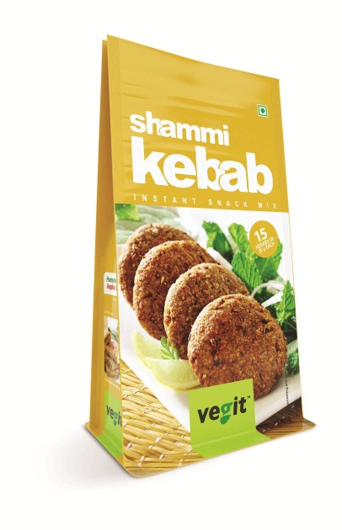
This mother’s day allow your mother to enjoy the delectable and scrumptious flavors of Vegit Ready to cook snack mixes. Each snack mix has been prepared keeping in mind the attention to the recipe, taste, eating experience and the joy involved in preparing these instant and convenient to prepare snack mixes.

The specialty of these Vegit ready-to-cook snacks is that they can be prepared with a “Twist”, on Mother’s day you can add the flavor most preferred by your mother and surprise her with mouthwatering snack mixes. Vegit gives you a ready “Twist” recipe booklet along with each pack, to try out something new each time.

The excitement to make these is spread equally between the making and the eating. Where on one hand its preparation is simple, fast, neat and ready, it simultaneously presents delicious food that can be authentically served in a heartwarming way.

These snack mixes are recognized for its time-saving, cost-efficiency and extended storage life, as all the products are processed to international quality norms and have natural ingredients.

Vegit’s healthy range of mouth- watering traditional Indian snacks includes:
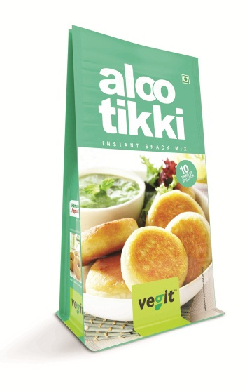
- Aloo Mash (Potato Flakes) saves the time of boiling/peeling/mashing of Potatoes and delight your mother with the goodness of mashed potatoes that gives the similar nutritional qualities as that of real potatoes with similar amounts of protein, dietary fiber, and vitamins. Additionally, dehydrated potato flakes can also be used as a nutritional base that complements a variety of products.
- Burger Patty- Spicy mix of potato flakes, vegetables and cheese to delight your senses! Avoid the tedious process of chopping and grating. Club Vegit patties with a burger and enjoy plateful of burgers within minutes.
- Aloo Tikki–Enjoying street food at home couldn’t get any easier and healthier! A perfect mix of Potato flakes and Indian spices shallow fried on tawa clubbed with Mint chutney gives you the real taste of Aloo Tikki!
- Aloo Bonda- Scrumptious mix of potato and onion bits with the classic touch of amchur powder dipped in besan and deep fried result in hassle free delicious bondas within minutes on your table
- Soya Roll- A snack outside of just potato! An appetizing fusion of potato and soya clubbed together with Indian spices and condiments offers an ideal evening snack prepared within minutes!
- Cheese Balls- A creamy cheesy delicacy that melts in your mouth, cheese balls can be prepared easily by making small balls and rolling them in bread crumbs, deep fried to be served hot with tomato sauce or mayonnaise!
- Harabhara Kebab- Bringing together the goodness of green peas, spinach and potatoes with the tang of kasuri methi, Harabhara Kebab is the ultimate snack for the health conscious.
- Shammi Kebab- Deep fried flattered snack of black gram and potato flakes makes for an ideal evening with friends and family
- Veg Cutlet- Enriching palate of carrots, french beans and capsicum available with the blend of mixed spice can serve as a delectable snack after being dipped in liquid batter and fried post rolling it in bread crumbs! A crispy snack that’s yummy inside!

About Vegit

Vegit is the agro division of Merino Group, spread equally between making of Potato Flakes and sumptuous Snacks Mixes and is committed to providing an international standard products that has been domestically produced. The integrated approach from complete agri operations from tissue culture to food processing has assured the consisted supply of best quality products and has established a sustainable market for itself both with the domestic and international buyers.
Vegit offers a range of snacks mixes which are all simple, fast, neat and ready to make and also exports the products and reaches out to the retail sector and also the industrial catering units, restaurants and hotels. Vegit is ISO 9001, ISO 14001, ISO 18001, ISO 22000 and HACCP certified.

For more information visit Vegit at www.vegit-merino.com

About Merino Group

Merino is a versatile manufacturer and marketer of Interior Solutions with a wide array of products for homes, offices, commercial and public areas and is also into Agro-Food business under the brand name Vegit. Merino is today a US$ 160 million group with diverse business interest and two primary lines of business – Paneling and Agro. Founded in 1965, Merino Group’s 6 operating companies are Merino Laminates, Merino Panels, Merino Besco, Merino Hanex, My Space and Vegit. The Group has a strong presence in 60 countries with more than 3000 employees and a strong channel of network of dealers, sub dealers and retailers.

For more information visit Merino Group at www.merinoindia.com

For more information contact:

Hitesh Ranot  Merino Group  +91-9582416329  hitesh.ranot@merinoindia.com | Pratibha Kashyap/ Swati Jain  Linopinion  +91-919891049987/ +91 9910734054  pratibha.kashyap@loweandpartners.com/ swati.jain@loweandpartners.com

