Vegit adds flavor to its Packaging
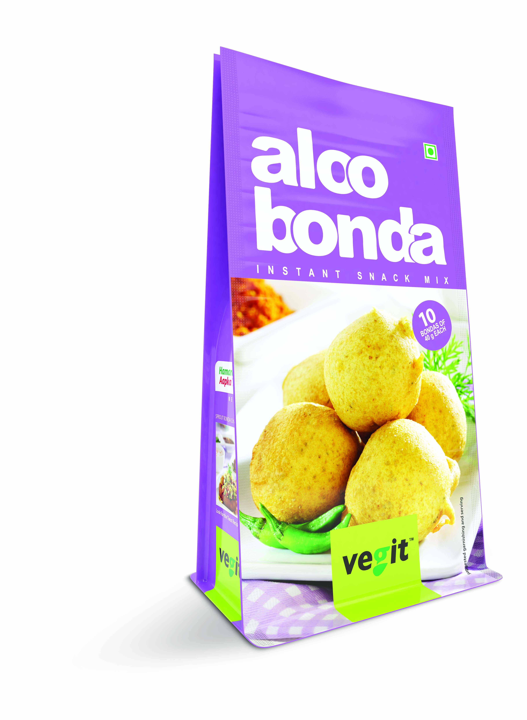
Unveils the new brand identity through new refreshed packaging and logo with a new tagline- Hamara Mix, Aapka twist
To stimulate the “senses” of consumers of any age, Vegit has unveiled new brand imagery with a refreshed packaging for its Snack Mixes, with a new tagline twist called “Hamara Mix, Aapka twist”. The objective behind the new packaging is induce the brand in retail segment with profound freshness, sustaining & building on the present equity of Vegit’s Snack Mixes & retaining the primary product Aloo Mash as constant at this stage. Vegit is one of the most recognized and respected brands in the ready to cook market in India - a name that delivers the very best in taste and add ease along with excitement to the cooking experience. The refreshed packaging for Vegit is designed to enhance the value and brand awareness of Vegit ready-to-cook food solutions.
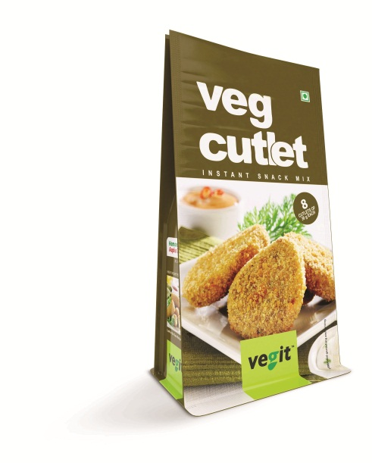
With the expected picking frequency of shelf level and consumer likings/noticing levels towards packaging, Vegit's consumer-friendly packaging has been carefully and creatively designed to meet the display needs of retailer as well as to ease and quicken the shopping process for customers.
Using carefully developed graphics and bold colors, the designs communicate great taste and great quality. The dynamic packaging showcases the method of preparation so as to entice and educate consumers about the taste sensations along with the nutritional value. The high quality graphics showcase appetizing images of the snack which is packaged, reflecting the mouth-watering food that can be prepared with a “Twist” as the consumer is free to mix and add his/her own flavor to the dish. Vegit gives you a ready “Twist” recipe booklet along with each pack, to try out something new each time.

Building on the existing equity of the product in market, the names and recipes of individual mixes are focused upon, while creating space for consumer engagement via recipes/ promos on back of pack. The three-hole grip adds carrying convenience for consumers. The new packages introduced include Snack Mixes like Aloo Tikki, Burger Patty, Aloo Bonda, Soya Roll, Cheese balls, Harabhara Kebab, Shammi Kebab, Veg Cutlet
About Vegit
Vegit is the agro division of Merino Group, spread equally between making of Potato Flakes and sumptuous Snacks Mixes and is committed to providing an international standard products that has been domestically produced. The integration of complete agri operations from tissue culture to food processing has assured the consistent supply of best quality products and has established a sustainable market for itself both with the domestic and international buyers.
Vegit offers a range of snacks mixes which are all simple, fast, neat and ready to make and also exports the products and reaches out to the retail sector and also the industrial catering units, restaurants and hotels. Vegit is ISO 9001, ISO 14001, ISO 18001, ISO 22000 and HACCP certified.
For more information visit Vegit at www.vegit-merino.com

About Merino Group
Merino is a versatile manufacturer and marketer of Interior Solutions with a wide array of products for homes, offices, commercial and public areas and is also into Agro-Food business under the brand name Vegit. Merino is today a US$ 165 million group with diverse business interest and two primary lines of business – Paneling and Agro. Founded in 1968, Merino Group’s 6 operating companies are Merino Laminates, Merino Panels, Merino Besco, Merino Hanex, My Space and Vegit. The Group has a strong presence in 60 countries with more than 3000 employees and a strong channel of network of dealers, sub dealers and retailers.

For more information visit Merino Group at www.merinoindia.com

For more information contact:

Hitesh Ranot  Merino Group  +91-9582416329  hitesh.ranot@merinoindia.com | Pratibha Kashyap/ Swati Jain  Linopinion  +91-919891049987/ +91 9910734054  pratibha.kashyap@loweandpartners.com/ swati.jain@loweandpartners.com

