
VEGIT’S EASY READY TO COOK MEAL FOR NAVRATRAS

  - To make your Navratras hassle free yet maintaining the flavor, Vegit brings Aloo Mash!

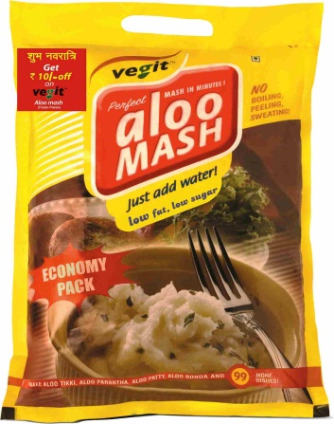
National, 12th April 2013: This Navratra let your taste buds relish the most flavorsome and mouth-watering traditional Indian food, Aloo Mash. The expediency of having Aloo Mash (potato flakes) in your kitchen lets you sit back through your fasting days and prepare food at your convenience in a very short time.
Fasting drains your energy throughout the day and limits you to preparing and savoring a limited range of food items. To create heartwarming delicious food, Vegit presents you with a way to save your precious time of boiling/peeling/mashing of Potatoes and yet delight your family with the goodness of Aloo Mash.
Vegit brings you the convenience of Aloo Mash (potato flakes) in your kitchen and a range of mouth-watering traditional Indian snacks to create magic moments for your family. Prepare snack mixes as it is or add your own unique twist and create unforgettable snacktime treats. They let you add your touch to the cooking process, as you can add the required salt according to your taste!
Aloo Mash from Vegit has appeared as a wonder product especially during Navratras as it is enriched with additional minerals and antioxidants to increase nutritional value and shelf life, hence serves better than fresh potatoes. It has controlled moisture levels which allow you to use for variety of instant dishes from Aloo. It gives the similar nutritional qualities as that of real potatoes with similar amounts of protein, dietary fiber, and vitamins.

About Vegit:
Merino is an integrated manufacturer and marketer of Interior Solutions with a wide array of world class products for homes, offices, commercial and public areas and in agro business, Merino began with the cold storage business and subsequently diversified into farming, biotechnology and food processing and have launched potato flakes and ready to eat snack mixes under the brand name “Vegit”
Vegit came into existence in the year 2005. Merino Group carried out a forward integration from Agro operations and cold chain and seed multiplication into processing. The first product launched in the retail market was Potato flakes. Subsequently the Group has increased the basket of offerings with more value added products. Now Vegit offers a complete range from Aloo Mash (Potato Flakes) to Snacks Mixes and also exports the products and reaches out to the retail sector and also the industrial catering units, restaurants and hotels
Vegit brand is spread equally between the making of sumptuous snacks and the pleasures of eating them, Vegit Snack Mixes which are all simple, fast, neat, and ready to make. The brand is associated with dishes that are tasty, authentic, and heartwarming to serve and consume. Also Vegit Potato flakes are potatoes that have been through a process to yield a packaged convenience food that can be reconstituted in the home in seconds by adding hot water or milk.

For more information contact:

Hitesh Ranot  Merino Group  +91-9582416329  hitesh.ranot@merinoindia.com | Pratibha Kashyap  Linopinion  +91-919891049987  pratibha.kashyap@loweandpartners.com

